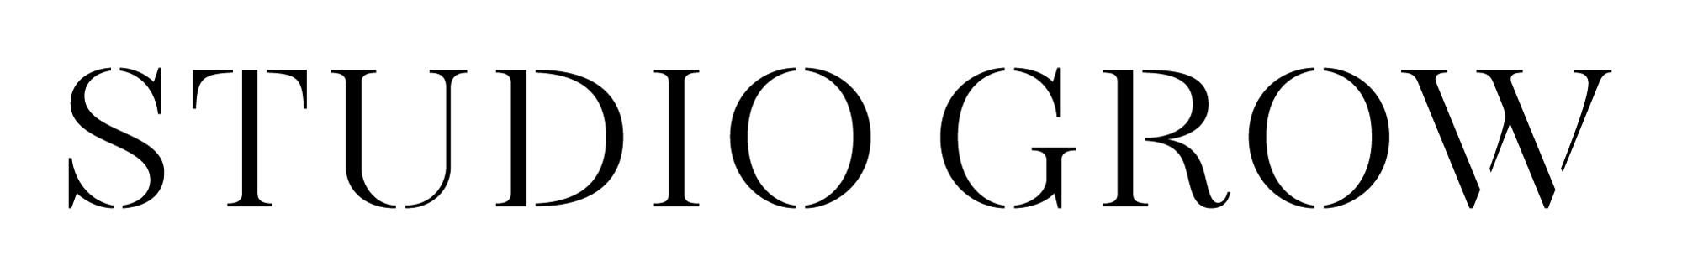

Get a Party Started!

25% Off Our Introductory Offer
Name: Phone #

$15
STUDIO CREDIT

Name:
Phone number:

$30
STUDIO CREDIT
Name:
Phone number:

$45
STUDIO CREDIT
Name:
Phone number:

$60
STUDIO CREDIT
Name:
Phone number:

$75
STUDIO CREDIT
Name:
Phone number:

